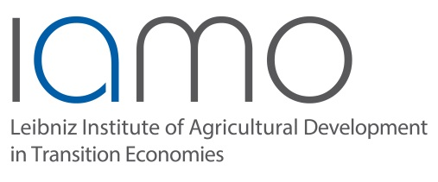
Vacancy Announcement

The Leibniz Institute of Agricultural Development in Transition Economies (IAMO) in Halle (Saale), Germany, invites applications for a
Ph.D. position
“Biocluster development pathways in different regional innovation systems”
within the project: “The Role and Functions of Bioclusters in the Transition to a Bioeconomy” (TRAFOBIT), funded by the German Ministry for Education and Research (BMBF).
TRAFOBIT investigates the role of so-called bioclusters in which businesses, governments, research institutes and universities work together with the aim to replace our current fossil based sources of carbon with renewable ones. This is a daunting task that requires systemic innovations, or ‘transitions’, that fundamentally change existing economic and technological structures.
The TRAFOBIT project explores the innovation processes that occur inside bioclusters, the embedding of bioclusters in their regional and (inter)national value chains and the possible transition paths of bioclusters in the future. The project has an interdisciplinary perspective aiming to combine theoretical insights and methods from sociology, innovation science, ecological economics and mathematics.

Tasks

The research of this PhD candidate aims to develop a method with which the development phases of bioclusters within different regional contexts can be explored. Based on an international cross-case comparison of biocluster development trajectories, the PhD candidate will identify some of the causal mechanisms and innovation motors at work within bioclusters. The results will be used to define and calibrate a computer model (for instance agent-based model or system dynamics model) to explore how different regional circumstances of the same type of clusters can lead to different development paths.

Requirements
- Suitable candidates have a Master’s degree or equivalent in (computational) social science, (agricultural) economics, economic geography, innovation science, or science and technology studies.
- Some experience with modelling approaches such as system dynamics or agent-based modelling is considered to be a strong asset.
- The candidate should have an independent mindset, strong communication skills and a willingness to spend time abroad.
Terms and conditions
The successful candidate will conduct his/her PhD research at the IAMO department of Structural Development of Farms and Rural Areas in Halle (Saale). He or she will become a member of the IAMO Graduate School and apply for a doctoral degree from Martin-Luther-University Halle-Wittenberg.
The salary is calculated according to TV-L 13 based on a 75% of full time basis. The position is for 3 years and the preferred starting date is July 1st 2017.
IAMO (http://www.iamo.de) is a public research institute that pursues basic and applied research in the field of agricultural economics and related fields. It is a member of the Leibniz Association, a German network of non-university research institutes. IAMO is an equal opportunity employer and particularly welcomes applications from female candidates. Physically handicapped persons with equal qualifications will be given preference.
Application
Interested candidates should send a set of application documents in English that include:
- Letter of motivation (maximum 1 page);
- Curriculum vitae;
- Names and contact information of two academic referees.
This set of application documents should be sent by e-mail to Dr. Frans Hermans (Hermans@iamo.de).
Closing date for the application is May 12th 2017.

Further information:
Dr. Frans Hermans
Leibniz-Institut für Agrarentwicklung in Transformationsökonomien (IAMO)
Theodor-Lieser-Straße 2
06120 Halle (Saale)
+49 345 2928-134
hermans@iamo.de

https://www.iamo.de/en/research/projects/details/trafobit/

